Boat Race Day
Festival of Rowing 2023
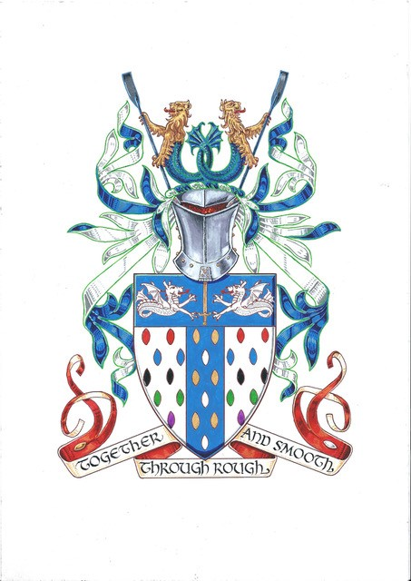

SUNDAY 26th March @ 13:45
ENTRY FORM
The flotilla is for a maximum of twenty traditional rowed/paddled craft to escort the
Queen’s Row Barge ‘Gloriana’ over the four-mile Boat Race course.

The flotilla will be followed by a Skiff Race, Pilot Gigs and Watermen’s cutters
competing for The Oxbridge Waterman’s Challenge trophies.

The Cox from all participating craft MUST attend the 11:15am briefing
at University of London Boat Club 81 Hartington Rd, Chiswick, London W4 3TU
no attendance = no participation (the river is closed and controlled by the PLA for this event)

Following the briefing all boats will proceed downstream to Putney for the row over.

Full Guidance Notes will be issued when this entry form is accepted, and the necessary fee is received.

Refreshments may be purchased at ULBC before boating and after the row.

ENTRY in the FLOTILLA or SKIFF RACE or PILOT GIG RACE (delete as necessary):

Boat Name:………………………………………………………………………...………………..…

Type of boat: ……………………………..……………Total number on board: .…………………

Contact Name:…………………………………..…..Contact No: …...…..…………………………

Contact Email: ………………………………………………..……………………………………….

Entry fee ~ £25 per person in the boat

**********ENTRIES CLOSE ON THE 14th MARCH**********

Online payments may be made with
‘Boat Name’ FLOTILLA 23 as the reference to -
NatWest Bank, Sort Code: 56-00-18
Account number: 63696444
Please return this entry form to rowlane@gmail.com
or with cheques made payable to: TTRA, c/o 47 Therapia Rd, London, SE22 0SD
Both the flotilla and skiff race as well as the Oxbridge Waterman’s Challenge are being organised by the board of the Thames Traditional Rowing Association with the kind permission of
The Boat Race Ltd.

