**MANNINGTREE PADDLE & OAR FESTIVAL**

**8th and 9th JUNE 2013**

**8th June – canoes and kayaks**

* **Try out a canoe/kayak – qualified instruction – FREE**
* **Hogmarsh Duck Hunt – for canoes, kayaks and small rowing boats**
* **Challenger13 – 3 mile route for experienced canoeists**

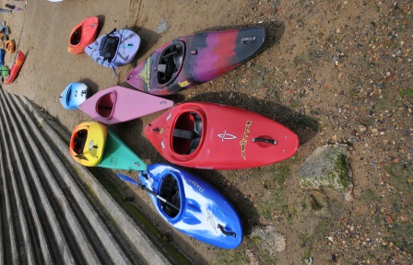

**Skiff and Gig Racing – a spectacular sight!**

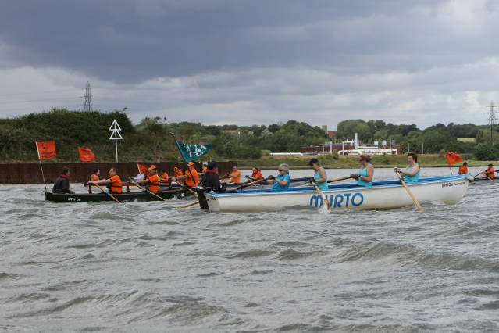

* **The Wrabness Challenge on 8th June - a 7 mile route**
* **The Mistley Triangle on 9th June - a 3½ mile route for all kayaks, skiffs and gigs**

**Come along to the marquee for tea, coffee, pastries and cakes plus BBQ**

**Take part in the blindfold rowing on 9th June – open to all (boat provided!) at 13.00**

**Trophies, medals and prizes to be won on both days!**

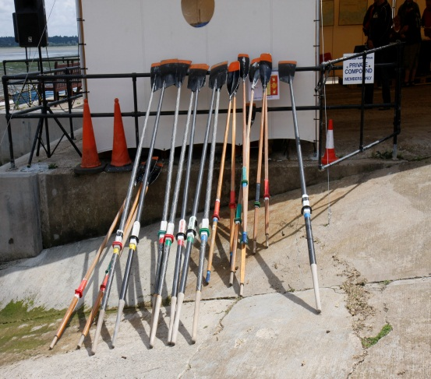

**Come along Saturday 9am (taking part)/10.30 (spectators) and Sunday 11.00 onwards to this unique event – great prizes!**

**See Stour Sailing Club Website (www.stoursailingclub.co.uk) for more details**

**All events take place at the beach in front of the Stour Sailing Club, 10 Quay Street, Manningtree, Essex, CO11 1AU**